Phase 6 — Project Testing
The backend APIs were tested using Postman. The table below summarizes the test cases and results, followed by supporting screenshots for each API test.
Testing Report
Test Case | Expected Result | Actual Result | Status
Register user | Account created | Account created | Pass
Login | JWT generated | JWT generated | Pass
Upload material | File uploaded | File uploaded | Pass
Generate summary | Summary generated | Summary generated | Pass
Generate flashcards | Flashcards generated | Flashcards generated | Pass
Generate quiz | MCQs generated | MCQs generated | Pass
Generate study plan | Plan generated | Plan generated | Pass
API Testing Screenshots
1. User Registration — POST /api/admin/users
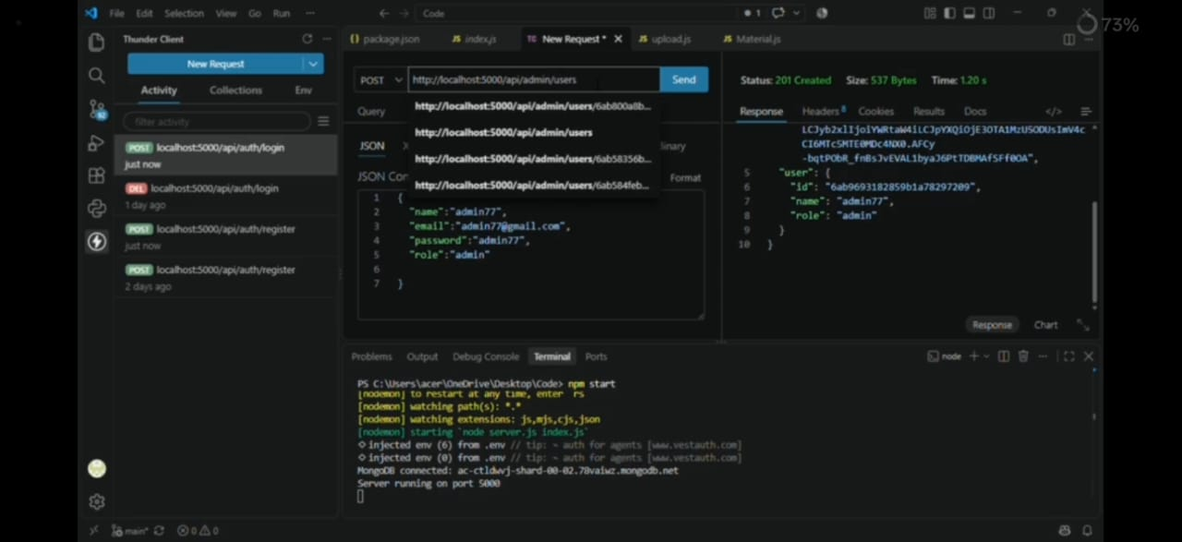

2. User Login — POST /api/auth/login
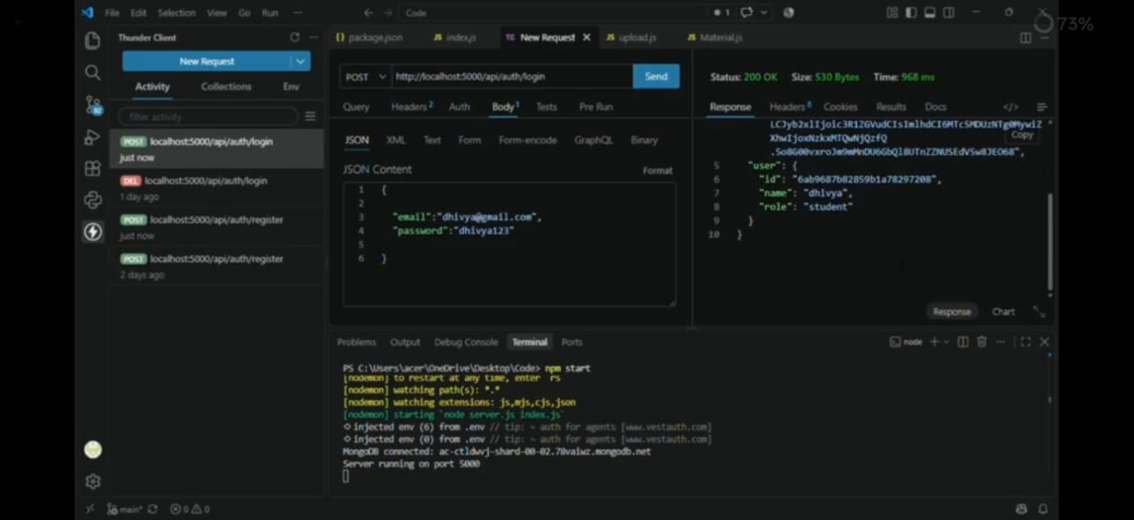
3. Upload Study Material — POST /api/admin/users
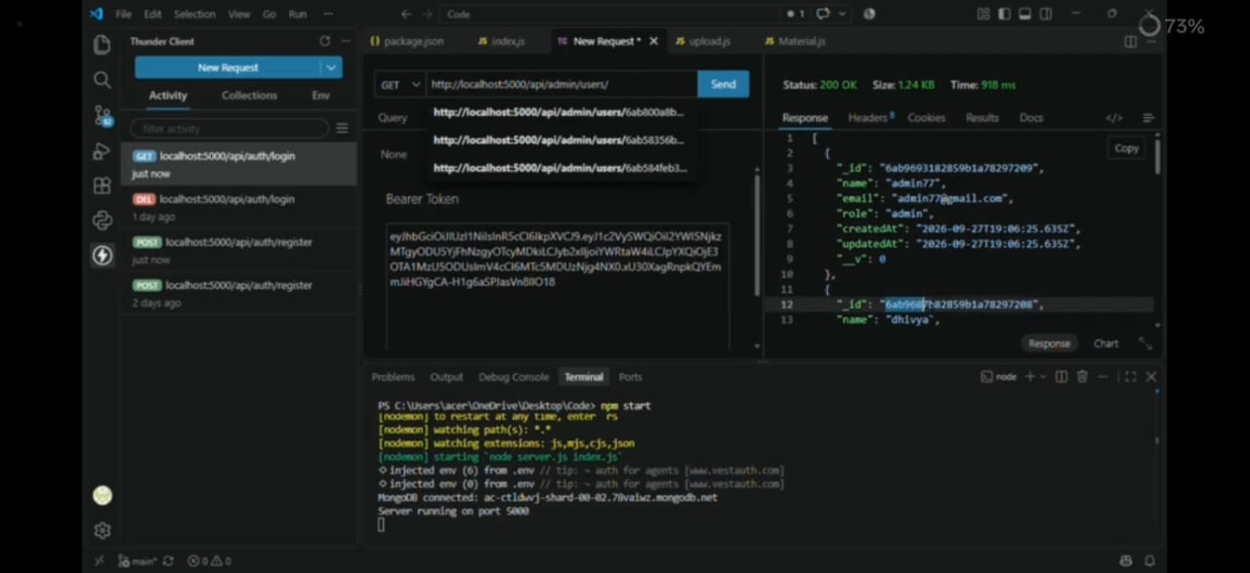

4. Generate AI Flashcards — POST /api/auth/logout
